20 December 2023
Version 0.1

C3 Limited
05 December 2022
Version 1.0
Architecture as a Service
Data Platform
Architecture & High-Level Design

Document Information
Document ID | Data Platform Architecture & High-Level Design
Document Owner | Andrew Bennett  Sayani Sanyal  Ravi Ahuja
Issue Date | 20/12/23

Document History
Version | Status | Issue Date | Author | Changes
V0.1 | Draft | 20/12/23 | Andrew Bennett  Sayani Sanyal  Ravi Ahuja | Initial draft focusing on current state and target architecture. Excludes roadmap.

Document Review
Role | Name | Version
Reviewer | Grant O’Neill | 0.1

Document Sign-off
Role | Name | Signature | Date

Contents
1 Introduction 5
1.1 Purpose 5
1.2 Scope 5
1.3 Document Organization 5
2 Business Context and objectives 6
2.1 Business Context 6
2.2 Overview of Business Goals and Intended Outcomes 7
2.3 Success Criteria of the Project 8
2.4 Data Requirements to support Business Objectives 9
2.5 Stakeholder segmentation 9
3 Current State Architecture 12
3.1 Current State System topology and interactions 12
3.1.1 Current State System and Integration Catalogues 14
3.2 Enterprise Architecture strategy 14
3.3 Operational Systems & related Business Process 15
3.3.1 Forestry process flow across current state systems 16
3.3.2 Example business events realised by current state systems 18
3.3.3 Elevating the essential aspects of the current Forestry process 20
3.4 Current Challenges 26
4 Looking Forward 30
4.1 State of the industry 30
4.2 Technology directions 30
4.3 Implications and considerations for C3 30
5 High Level Architecture & Design 31
5.1 Architecture Principles 34
5.2 Data Architecture 36
5.3 Recommended Tools and Tech Stack 37
6 Data Volume and Velocity 39
6.1 Specifications around DW SQL server 39
6.2 Data Velocity and Real-Time Requirements 40
6.3 Scalability and Capacity Planning 41
7 Implementation roadmap 44
7.1 Epics & User stories 44
7.2 Implementation plan & roadmap 44
8 Appendix 45
8.1 Data Mesh 45
8.2 Current State Collateral Referenced 47
8.2.1 Infrastructure topology 47

- Introduction
  - Purpose
The purpose of this document is to outline the data requirements for implementing a modern data platform at C3. In support of this goal this document additionally includes a roadmap of system integration opportunities to remediate the overall technical ecosystem so that the data platform can realise the proposed business goals. This document serves as a reference guide for stakeholders, architects, and developers involved in the design, implementation, and management of the platform.
  - Scope
This document focuses on identifying and documenting the data requirements necessary to meet the business objectives of C3. It covers various aspects such as data sources, data volume, data types, data quality, source-to-target mapping, data security, data processing and analytics, data integration, data storage, data visualization, and performance.
  - Document Organization
The document is organized into sections that correspond to different areas of data requirements for the modern data platform. Each section provides an overview, requirements, and considerations related to that specific area.
- Business Context and objectives
  - Business Context
“C3 is a leading provider of product handling solutions, on wharf and beyond, working in partnership with exporters, importers and shipping lines across New Zealand and Australia.”
C3 operates in 23 locations across New Zealand and Australia, with the majority of locations in New Zealand. C3 branches are generally located at ports but include logistics hubs for forestry, rail and trucking.
C3 is part of the LINX Cargo Care Group. In 2018 C3 acquired the Pedersen Group, a provider of wood chipping and woodyard management services to pulp and paper mills and forest owners in Australia and New Zealand.
C3 services support their customers’ supply chain and include:
- Log logistics and stevedoring through to export.
- Cargo logistics through to export. C3 manage a variety of cargo types, including:
  - Bulk cargo such as wood chip, coal or stock feed.
  - General cargo like timber and pure car and truck carriers (Roll on/Roll off –or RoRo).
  - Specialised project cargo such as heavy machinery, over-dimensional or out-of-gauge break-bulk.
- Port services.
Delivering these services requires the execution of several operational functions, including:
- Log marshalling and stevedoring.
- Export documentation.
- Forest harvesting.
- Woodchip stockpile management.
- Warehousing.
- Container consolidation.
- Transportation.
- General and bulk cargo.
- Pure car and truck carriers / roll on roll off.
The current state technical ecosystem of systems at C3 has evolved over time to support the above operational services and activities. The current state has a number of recognised issues in terms of reliability and unnecessary complexity that are proving difficult to operate and support.
C3 has asked Datacom to undertake a work package with the following deliverables:
- Complete the capture of the current state of the integrations.
- Complete a Data Discovery and Design Phase for a future state data platform.
This includes a plan for its implementation.
  - Overview of Business Goals and Intended Outcomes
The following are the primary goals and intended outcomes of this engagement as captured in the initial workshop.
- The establishment of sound data practices to support sound business operations:
The following workshop statements capture the main aims:
  - “Well defined and easily defined/modified data retention and data archiving.”
  - “Managed data growth, legal requirements met, etc.”
  - “Structured data / Customer access / Data owners.”
  - “Customer satisfaction, good customer service.”
  - “Define what is real time, daily, weekly requirements.”
- Establish the capability to deliver data insights for internal and external customers as needed.
The following workshop statements capture the main aims:
  - “Be able to track current financial and operational performance.”
  - “Customer track and trace.”
  - “Management information for monitoring customer volume trends.”
  - “Able to populate operational kpi's.”
  - “Management reporting info available to managers, and managers able to run their own reports.”
  - “Information across all operational sites.”
  - “External customer satisfaction.”
  - “Ability to easily measure kpis.”
  - “Dashboards for customers.”
  - “Granularity so we can interrogate as we wish.”
  - “Using data for business improvement.”
  - “Internal customer satisfaction.”
  - “One source of truth.”
- Establish the capability to deliver data pathways as needed.
The following workshop statements capture the main aims:
  - “Provide data integration with external consumers. Well defined and reusable.”
  - “Manage data from all sources , eg all current Logistics operations management systems.”
  - “Information across all operational sites.”
  - “One source of truth.”
  - “Not to be told - 'no, we can’t do that' because data is on different platforms etc.”
- Provide the capability for self-service interactions.
The following workshop statements capture the main aims:
  - “Management reporting info available to managers , and managers able to run their own reports.”
  - “External customer satisfaction.”
  - “Dashboards for customers.”
  - “Manager Able to interrogate data base with a number of filters.”
  - “Self-sufficient managers.”
  - “Bad: No ability for external customers to create their own data insights.”
- Deliver a platform that is reliable in terms of uptime and data quality, and that is easy to support.
The following workshop statements capture the main aims:
  - “Claims form data outages, e.g. ship can’t sail because of manifest info failure.”
  - “NO CLAIMS FROM DATA OUTAGES.”
  - “Getting customers hooked on data, then letting them down with outages and failures.”
  - “System uptime.”
  - “Customer satisfaction, good customer service.”
  - “External customer satisfaction.”
  - “One source of truth.”
  - “Granularity so we can interrogate as we wish.”
  - “Internal customer satisfaction.”
  - “Skills to maintain data and add reporting are commonly sourced in the industry. Don’t want to be an Island!”
  - “DW that is supported and not requiring niche skills.”
- Removal of unnecessary dependencies between data pathways causing constraints.
The following workshop statements capture the main aims:
  - “Separation of operational data.”
  - “Operational systems do not use the data platform.”
  - Success Criteria of the Project
The following success criteria are composed from statements captured in the initial workshop and subsequent discussions. Note that these criteria will need to be reconfirmed and adjusted as part of establishing a subsequent delivery project plan:
- Elements of good data governance have been developed, including:
  - Data classification and glossary defined.
  - Data retention and archiving policies defined.
  - Data architecture principles defined.
  - An initial data governance framework has been established.
- A pilot of the data platform has been completed. The pilot will exercise initial examples of the following:
  - The data ingestion pipeline.
  - Transform and load to the data warehouse.
  - Ability to use and manipulate the data in a variety of ways including reports, dashboards, and analytics.
  - Access by internal and external identities, role-based access.
- Qualities of the data platform support the business objectives:
  - Use of industry standard skill sets.
  - Reliability.
  - Ease of use, self-service, etc.
- An executable roadmap with achievable milestones has been agreed:
  - The roadmap transitions legacy systems and integrations to an agreed future state in a series of low-risk incremental milestones.
  - The roadmap delivers recognisable benefits for agreed stakeholders at each milestone.
  - Data Requirements to support Business Objectives
Detailed data requirements will be addressed in the next stage of delivery.
For the Forestry domain see section 3.3 Operational Systems & related Business Process for descriptions of the critical data elements and data sources, and the current integration and governance structures in place.
  - Stakeholder segmentation
The following stakeholder groups are derived from user stories provided by C3:
Stakeholder Group | Description
Customer | C3 services used by customers include forestry / log logistics and stevedoring, cargo logistics, and port operations services.  The following are examples of C3 customer stories.  “I want to”:  - Consume data about my inventory so that I can analyse it and report on it myself.  - Monitor the live progress of my vessel loading so I can be confident it is on track.  - Monitor the live progress of my cargo exchange so I can be confident it is on track.  - Request data and dashboard services from C3 as part of my contracted services.  - Track and trace my cargo.  - Access my data in a raw format.  - Run predefined reports or design my own.
Branch Manager | C3 operates in 23 locations across New Zealand and Australia.  The following are examples of C3 branch manager stories.  “I want to”:  - See how my branch is performing compared to others.  - Use data to forecast and plan for my operations.
Checkpoint | C3 checkpoints are part of the inbound logistics pathway. Trucks pass through the checkpoint on the way to the port or yard. Logs are checked against customer dockets and scaled for volume.  The following are examples of checkpoint staff stories.  “I want to”:  - See what locations are open so I can allocate dockets to the right place.
Yard | Yards are where logs and cargo are marshalled in readiness for export or temporarily stored during import.  The following are examples of yard stories.  “I want to”:  - Access location information so I can plan yard operations.  - Get the dockets in a location so that I can check the dockets are recorded correctly.  - Get the details for a log so that I can check it is in the correct place.
Planners | Planner handle allocation to shipments for export.  The following are examples of planner stories.  “I want to”:  - Access location information for a shipment so that I can provide this to the inspectors.  - Provide customers the finalised details for loaded vessels.
Other stakeholder groups with significant IT service involvement, but are outside the scope of this engagement, include:
Stakeholder Group | Description
Corporate | Provision of corporate services including HR and payroll, finance, etc.
IT Services | Provision of IT support and services, including custom development, across the organisation.
Fleet | Provision of fleet management services.
Pederson | Pederson Group provide wood chipping and woodyard management services to their customers.

- Current State Architecture
  - Current State System topology and interactions
The following diagram shows the general current state system topology and interactions supporting the Forestry business operations. In summary, the topology has the following features:
- A combination of on-prem and cloud, generally AWS, deployed systems.
- Functional decomposition across the estate is mixed with multiple crossovers between systems that touch the same data sets and functions.
- A mix of integration patterns including API, flat file export / import, email attachment scraping, use of SQL database intermediaries including the data warehouse, and manual duplication of data captured in client systems.
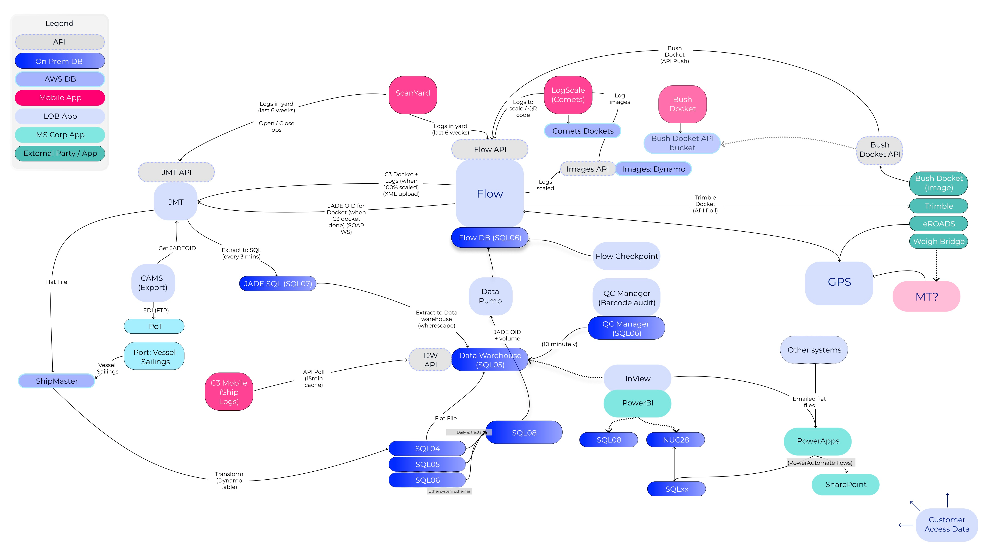
Figure 1 - Current state landscape

    - Current State System and Integration Catalogues
Current State System Catalogue
TBC
Current State Integration Catalogue
TBC

  - Enterprise Architecture strategy
C3’s enterprise architectural practice reflects several driving factors and landscape features:
- JADE Master Terminal (JMT) provided a foundational capability that aligned to and supported C3’s early, and indeed current, line-of-business needs.
- Extensions for business capabilities, such as reporting and analytics, were built around the central platform.
- As the need for evolution exceeded the pace at which JMT could be modified, or were incompatible with the capabilities that JMT was designed to support, additional solutions were developed around JMT. With JMT retaining the role of the master data system, any extension required some form of integration with JMT or with data mastered in JMT.
- There are several themes that are normal in these situations:
  - The additional solutions were naturally developed as point solutions – there does not appear to be a strategic expectation or plan for how past and current solutions would be evolved and created, and what technology stack they would adhere to, for integration at least. Investing in foundational analysis and frameworks and platforms was not visibly pertinent as a strategic investment.
  - The landscape of solutions and integrations now imposes a significant burden in terms of ‘keeping the lights on’, or the risk that they may not turn on. This leaves little space for the strategic analysis and thinking, through to the proof-of-concept stage, to support the evolution of the enterprise framework and strategy.
C3’s engagement with Datacom and the delivery of this document is a response to the above constraints on progressing C3’s enterprise architecture. Execution of the recommended next steps of this report will not only deliver a pilot of the proposed platform but also establish a pattern of delivery based on an architecture-led understanding of the business domain within an enterprise data framework.
  - Operational Systems & related Business Process
The systems and data sets involved in the Forestry process are depicted below.
A key aspect of the process is that major state changes are affected through physical events. Examples include the movement of the truck through a checkpoint, unloading the truck, the movement of logs, and loading individual logs onto a ship for export.
See section 3.1.1 Current State System and Integration Catalogues for a list of the applications and integrations that support the process depicted below.
    - Forestry process flow across current state systems
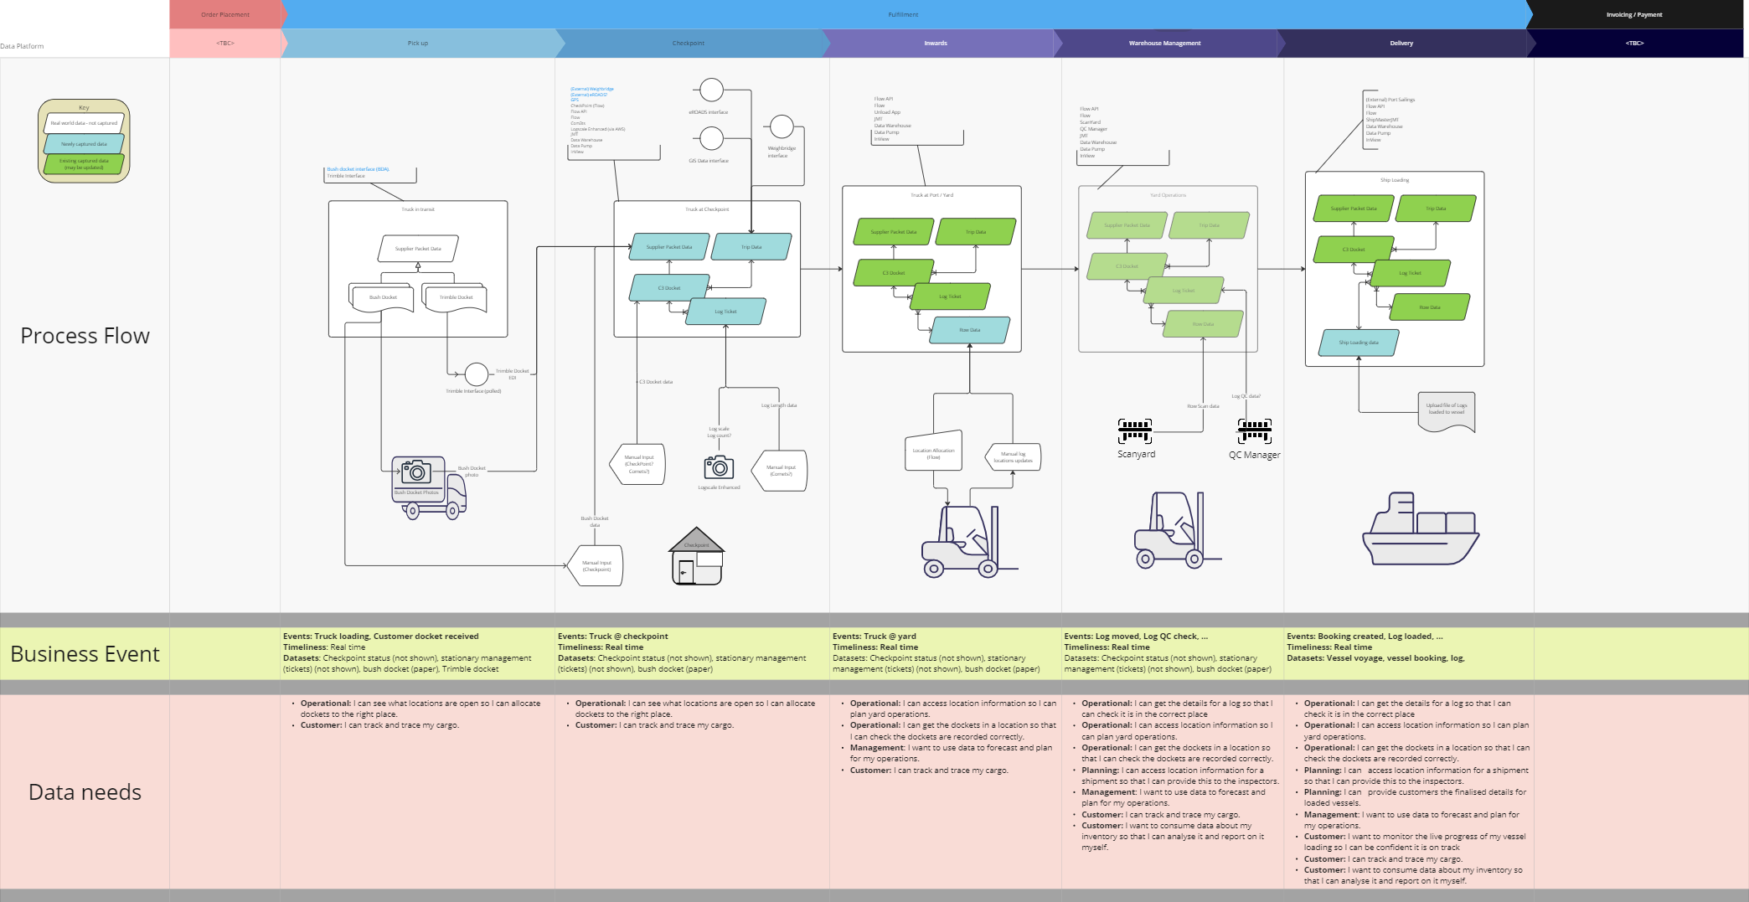
Figure 2 - Current state landscape

The Forestry process flow is itself fairly clear and consistent. Complicating the implementation of the process with current state systems is the number of systems involved, the variety of integation styles employed, and the interaction with external systems that C3 does not control and which have varying degress of modernisation.
Whilst the latter issue is outside of C3’s ability to address, there is a clear need to both standardise the integration styles employed and, ideally, rationalise the number of systems involved in supporting the process.
Any effort to modify the implementation supporting the above process needs to take into account the ‘data needs’ at each stage; the need to expose the data being captured not only to support the process itself, but to provide insight into the process so that process can be monitored and triaged in the event of failure, and to support sound business decisions around potential efficiency improvements.
    - Example business events realised by current state systems
The following are examples of two of the business events within the Forestry process showing how they are supported by current systems and integration configurations.
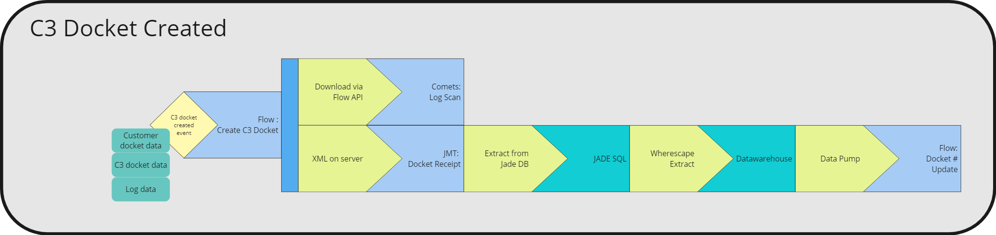
The creation of a C3 Docket propagates across multiple systems and databases, including the Data Warehouse, to propagate the shared identifiers, aka JADE OIDs, used across systems.
The use of the Data Warehouse, the timeliness of data transfers, and the lack of explicit acknowledgement between integrated systems leads to the process being overly complex, unnecessarily latent, and difficult to triage in the event of failure.
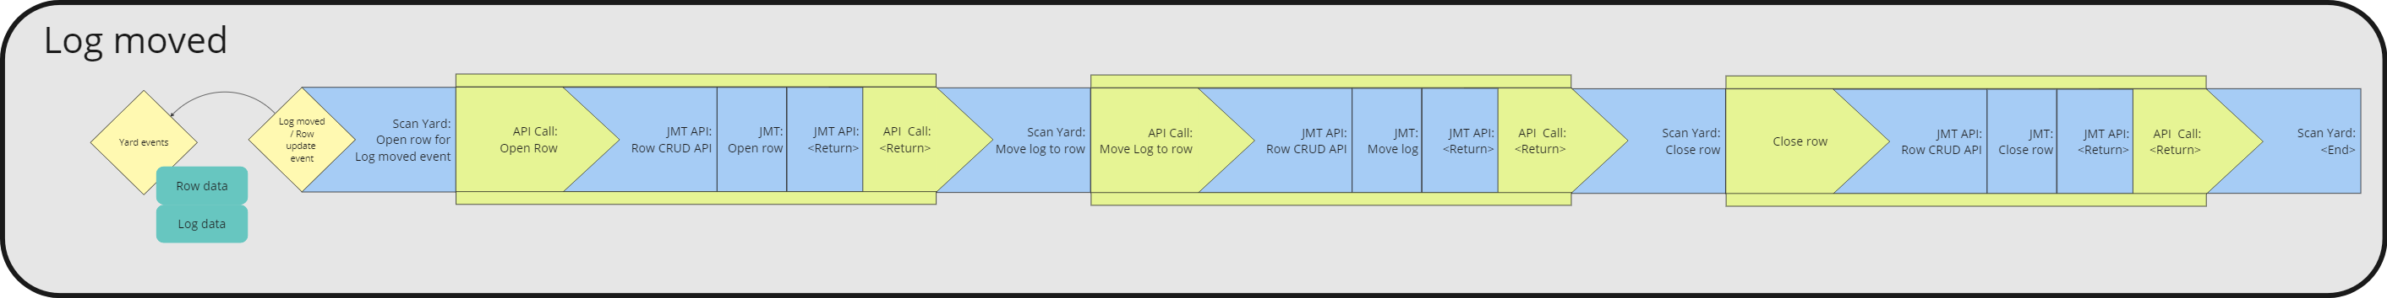
The movement of a log in the yard from one row to another propagates from ScanYard to JMT where yard management is mastered.
Integration with JMT requires the use of ‘fire and hope’ semantics due to the lack of an acknowledgment response from JMT. To mitigate this the API process inserts a time-based pause in the hope the operation within JMT has actually completed, again introducing unnecessary latency and complexity in the triage of any failures. In addition, the need to expose the requirement to ‘open’ and ‘close’ a row before logs can be moved means knowledge of the internal workings of JMT is forced onto systems integrating with it increasing unnecessary dependencies for future maintenance and evolution.
    - Elevating the essential aspects of the current Forestry process
To support the development of a future state architecture an understanding of the ‘essential’ aspects of the current state situation is very useful, namely those aspects that must be retained in the future state separated from those aspects that are only a feature of the current implementation.
The aspects, both essential and current state features, being discussed here include:
The essential:
The essential aspects can also be viewed through canonical models of the business. Canonical models represent the source elements of the business flow, the elements that cannot be replaced or removed without the business flow itself becoming invalid.
- The business events that occur.
- The business data for those events.
- The business requirement or process and business rules that must respond to those events.
The current state features:
The current state features can also be viewed as technical constraints, simply because progress will always require that current structures be reworked or broken down so they can be rebuilt to support an updated frame of understanding. The ongoing aim of any technical solution development is to reduce the impact of constraints while enhancing the canonical elements of the business.
- The current state systems that provide the functionality implementing the business requirements / process and rules.
- The current state integrations that allow systems to communicate.
Road Mapping
A roadmap from current to future state can then be considered as a series of milestones that deliver either the promotion of canonical elements and / or the reduction of technical constraints.
      - Essential - Event mapping to business function and data set
The following diagrams show a simple representation of the mapping from business events to the business process and rules that should respond to that event and the data that makes up the event.
Events can affect both master data entities, such as logs and customers, as well as transactional data, such as customer dockets and vessel sailings.
The Forestry process events are shown below broken into two broad areas;
- Inwards goods management where logs are delivered to the yard, and
- Yard management where logs are received into the yard, managed and moved within the yard as required, and then loaded onto ships for export.
Inwards goods management
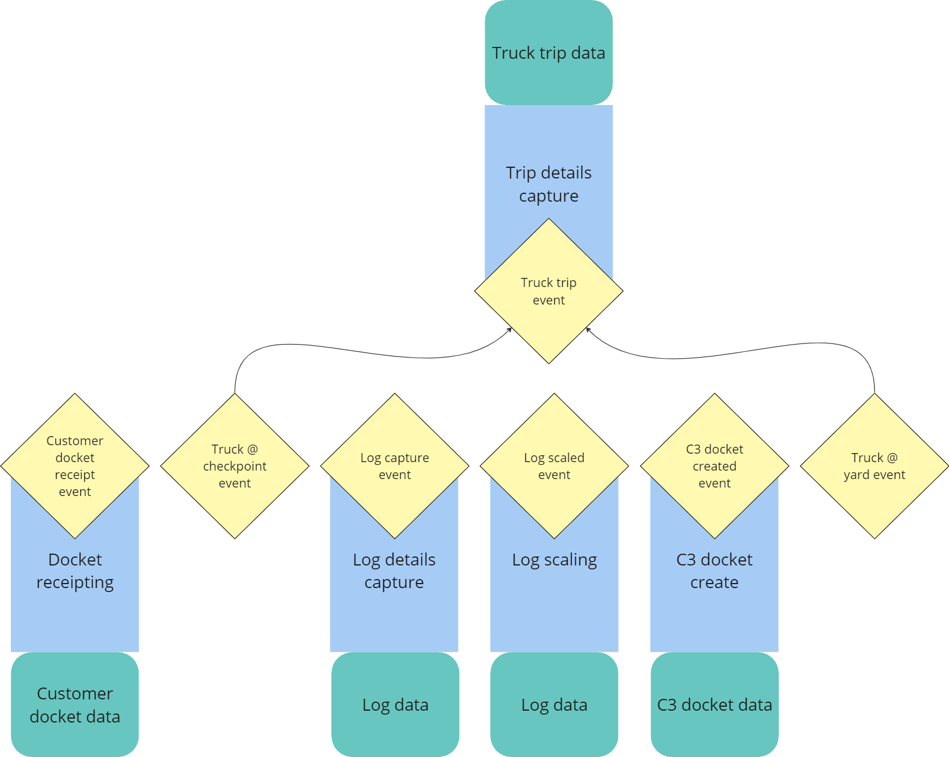
Inwards good management events manage the interaction between two key master data entities, namely customers and logs. Log data has multiple events updating data about the log, in particular its volume. The fleet assets, namely trucks, are also captured for relevant management, i.e., fleet management.
Transactional data captured to represent these interactions includes customer dockets, C3 dockets, and trip details.
Yard management
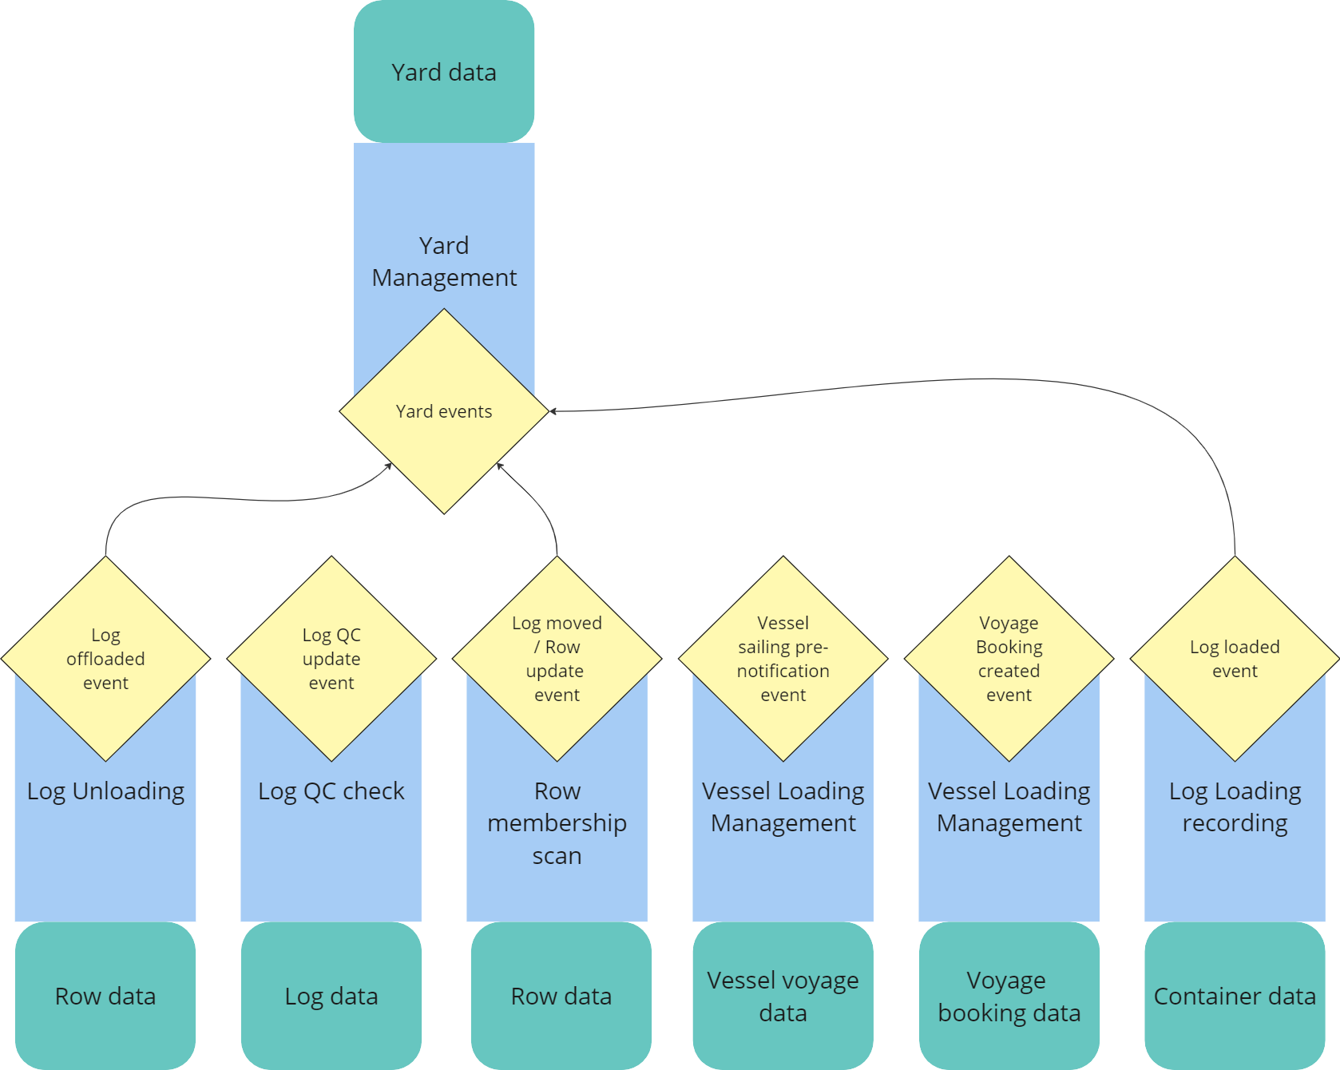
Inwards good management events continue to manage the interaction between customers and logs and adds the master data entity yard. Log data continues to be updated by multiple events including quality checks, moves between rows, and loading onto a ship.
Transactional data captured to represent these interactions includes row moves within the yard, quality control checks, vessel bookings, and log loading.
      - Current state features - Allocation of business function to systems
The following diagram depicts the allocation, or allocations, of business function to current state systems.
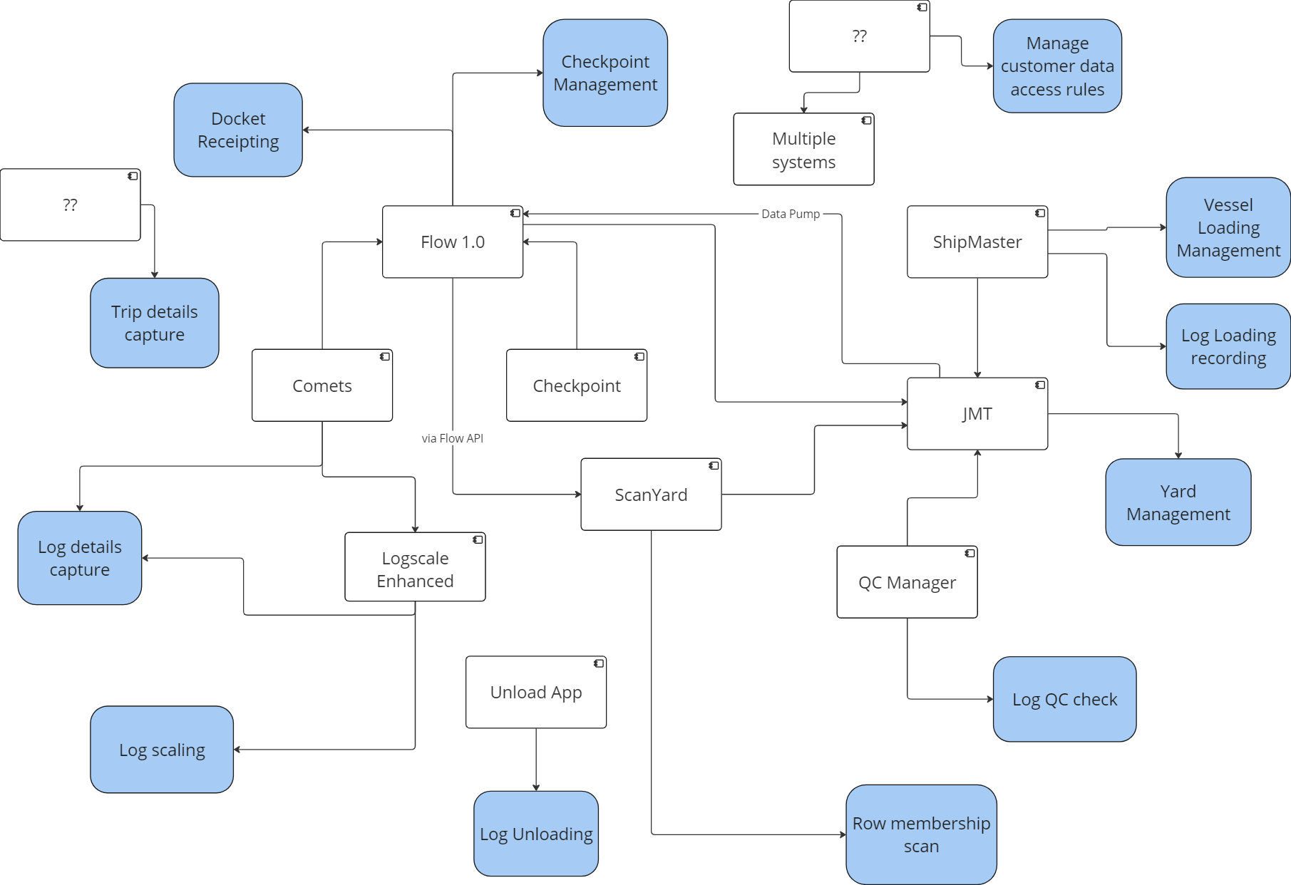
Whilst this diagram is incomplete in its representation of the variety of business functions allocated to ‘LOB’ systems, it does indicate the opportunity to understand the IT landscape as a series of business functions separate to the systems that currently implement those functions.
Each of the above functions operates on multiple sets of business data, master data, transactional augmented by reference data. Whilst these data sets are not shown above for brevity, the result is that the business data is almost universally spread across all of the systems shown above.
The standard approach to managing the complexity of data spread is to define those systems that have the role of ‘Source system’, ‘System of action’, ‘System of record’, and ‘System of insight’ or reference for each entity. In C3’s case, the above role allocations would change over lifecycle phases of the key master data entity, namely ‘Log’. For other entities, such as ‘Customer’ and ‘C3 Docket’, the above roles can be allocated more simply.
The main reason for establishing the roles various systems have in the lifecycle of data entities is to aid mutual understanding so that architecture decisions can be made in a consistent manner to reduce the spread of complexity.
Other approaches to managing this role allocation exist on a spectrum of architecture choices, including:
- Managing the entire lifecycle and all roles for an entity within a single system, generally an off-the-shelf product but could also be an end-to-end custom-built solution.
Required changes to the logic or attributes of an entity are generally delivered as a new release of the entire system with consequential testing impact.
ERP solutions are an example of this approach. All roles for data entities are generally managed within the ERP, with some exceptions for external analytics. Where the ERP solution is well aligned with the organisation’s business process then the organisation benefits from well tested and industry wide upgrades that address their needs ‘out of the box’.
- Microservices where the entire lifecycle and all roles for an entity are managed behind an API defined exclusively for a given entity, or a bounded context of related entities.
Required changes to the logic or attributes of an entity are generally delivered as a new release of the specific microservice with little or no impact on other systems. Generally, this works best when the model the microservice is based on is well aligned with the organisation’s business process. The delivery of updates becomes simpler and faster because there are no unnecessary dependencies between functions provided across the IT landscape.
A downside of microservices is the need for high levels of experience and expertise in microservice design and management because they generally require a level of in-house implementation to deliver.
Reviewing the general themes rather than the specific implementation of the above two approaches, including hybrid solutions between them, within the C3 context suggests the following considerations:
- There are portions of the Forestry process and lifecycles that are ‘bulk standard’ and would benefit from the knowledge and standardised processes built into off-the-shelf products.
- There are other portions of the Forestry process and lifecycles that expose the opportunity for innovation and process improvement that would benefit from allowing C3 IT service delivery capability, in tandem with partners as required, to deliver their own IT components addressing those innovation opportunities.
- The provision of an independent articulation of the core business domain entities that can be updated and accessed by multiple systems could provide an explicit proxy that replaces the need to define the roles each system has in the lifecycle of key entities. The term Operational Data Store, ODS, in tandem with an event publishing capability, is used in this document to describe this approach.
The following consideration are relevant:
  - Regardless of where an entity is ‘mastered’ or initially created and allocated a unique identifier, it would be propagated to the ODS so it is available to other systems. These systems could either subscribe to the published event or ‘poll’ for the data they need.
  - The ODS interface should only implement an agreed enterprise definition of each business entity using a RESTful design approach. This is to benefit from similar advantages as the microservices approach in reducing dependencies due to ‘leakage’. Any functionality that is only needed for specific systems should not be implemented in the ODS.
That said, transitional steps may require the introduction of a façade to suit the needs of legacy systems and integrations. The façade would be modelled along the lines of the ‘Experience Layer’ of the Mulesoft API-Led architecture pattern to suit specific consuming systems. Note that this layer should be considered transitional, or at best an agreed ‘work around’, for as long as it is needed, i.e. for as long as consuming systems are not reworked to consume the RESTful domain model based APIs of the ODS.
  - The ODS should focus on data relevant to current operational contexts and purge or otherwise remove data that has fallen outside the operational window, be it a time window or other reason for retiring data.
This means that whilst the ODS may be a suitable repository for current operational reports and dashboards it would not be suitable for analytical activities nor activities that are about updating an historical event and the associated data. These needs must be met with other solutions, such as a data warehouse or compensating transactions in operational systems.
  - Given the rather tortuous route taken to propagate JADE OIDs through the various systems, some form of independent identifier solution and interface would appear to be relevant.
Whilst JMT’s JADE OIDs will need to be used for an extended period of time, it may be possible to offload the process of generating and then mapping JADE OIDs to a new global identifier to a separate interface.
  - Current Challenges
The initial workshop elicited a number of statements focusing on current challenges, summarised as follows:
- Lack of reliability
There have been a number of system outages recently that have pointed at overall solution fragility.
- Readily available skill sets
Currently expert niche skills are required to support the platform.
- Latency issues
A number of integration pathways result in late data delivery causing delays or incorrect operational responses and costs.
- No single source of truth
Compiling a single view of various business activities requires manual effort across multiple systems.
- No data management framework
With no data retention or governance rules defined there is no ability to manage data appropriately causing poor data usability.
- Large data volumes
Large data volumes cause performance issues and impede normal data management operations such as backups.
- Lack of cross-function data (e.g., finance data)
No ability to relate operational data to, for example, finance data to draw out insights.
- Lack of cross-location data
The same data across different locations is found in different systems.
- Lack of self-service ability
Users, managers and customers are beholden to the IT services team for new data reports. And likewise, IT services team are burdened with unnecessary effort providing the same data multiple times.
- Poor data fidelity
Data is not always in a format or granularity suitable for the purpose it is being used for.
- Conflicting data usage patterns
The data warehouse, designed to support reporting and analytics, is being used to support real time operational systems.
- Implementing changes or new functions difficult or lengthy
JMT, in particular, is difficult to update for new business requirements. Work arounds have been inevitable.
- Legal exposure
Outages have exposed C3 to cost and legal penalties.
Subsequent discussions highlighted the following issues:
- No central visibility of integration state.
There is no usable ability to see where bottle necks are, where processes might or have failed, and where additional resources should be employed.
- Difficult triage
Related to the need for niche skills and the complexity of integration between systems causes problems and delays in the process of triaging faults.

Workshop statement | Reliability | Readily available skill sets | Latency isues | No single source of truth | No framework to manage data against | Large data volumes | Lack of cross function data (e.g. finance data) | Lack of cross location data | Lack of self service ability | Poor data fidelity | Conflicting data usage patterns | Implementing changes or new functions difficult or lengthy | Legal exposure
Well defined and easily defined/modified data retention and data archiving. |  |  |  |  | X | X
Managed data growth, legal requirements met, etc. |  |  |  |  | X |  |  |  |  |  |  |  | X
Customer satisfaction, good customer service. | X |  |  | X
Define what is real time, daily, weekly requirements. |  |  |  |  | X
Be able to track current financial and operational performance. |  |  |  |  |  |  | X
Customer track and trace. |  |  | X | X
Management information for monitoring customer volume trends. |  |  |  |  |  |  | X
Able to populate operational kpi's. |  |  |  |  |  |  | X
Management reporting info available to managers, and managers able to run their own reports. |  |  |  |  |  |  | X |  | X
Information across all operational sites. |  |  |  |  |  |  |  | X
External customer satisfaction. | X |  |  | X
Ability to easily measure kpis. |  |  |  |  |  |  | X
Dashboards for customers. |  |  |  |  |  |  |  |  | X
Granularity so we can interrogate as we wish. |  |  |  |  |  |  |  |  |  | X
Using data for business improvement. |  |  |  | X |  |  | X
Internal customer satisfaction. | X |  |  | X
One source of truth. |  |  |  | X
Provide data integration with external consumers. Well defined and reusable. |  |  |  |  | X |  |  |  |  |  |  | X
Manage data from all sources , eg all current Logistics operations management systems. |  |  |  | X |  |  | X | X
Not to be told - 'no, we can’t do that' because data is on different platforms etc. |  |  |  |  |  |  |  | X
Management reporting info available to managers , and managers able to run their own reports. |  |  |  | X |  |  | X |  | X
Manager Able to interrogate data base with a number of filters. |  |  |  |  |  |  |  |  | X
Self-sufficient managers. |  |  |  |  |  |  |  |  | X
Bad: No ability for external customers to create their own data insights. | X
Claims form data outages, e.g. ship can’t sail because of manifest info failure. | X |  |  |  |  |  |  |  |  |  |  |  | X
NO CLAIMS FROM DATA OUTAGES. | X |  |  |  |  |  |  |  |  |  |  |  | X
Getting customers hooked on data, then letting them down with outages and failures. | X
System uptime. | X
Skills to maintain data and add reporting are commonly sourced in the industry. Don’t want to be an Island! |  | X
DW that is supported and not requiring niche skills. |  | X
Separation of operational data. |  |  |  |  |  |  |  |  |  |  | X
Operational systems do not use the data platform. |  |  |  |  |  |  |  |  |  |  | X

- Looking Forward
  - State of the industry
…
  - Technology directions
…
  - Implications and considerations for C3
…

- High Level Architecture & Design
The following high-level architecture and design is drafted taking into consideration the workshops and the pain points that was shared. The Architecture principles are outlined in the following section.
The programme will build an initial set of base Information Products (APIs) to meet business case objectives and allow other parties to contribute and enhance the Information Product ecosystem further over time.
When building both Products and Platform, the approach taken will be to first determine platform capability requirements for the Products identified in the business case, prioritise these requirements and then identify technology solutions and suitable delivery resources.
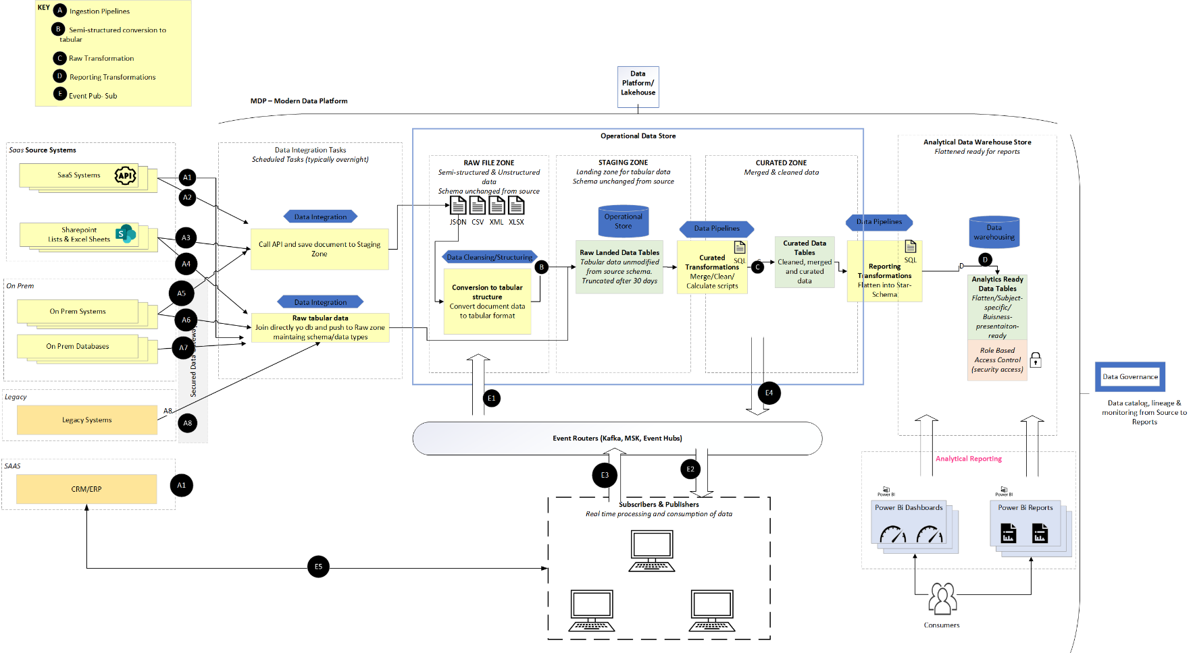
Figure 3 – High Level Architecture Diagram

The previous diagram depicts the High-level data architecture design proposed to address the challenges around data management, analytics, and integrations.
To fulfil business requirements for data and analytics both now and in the foreseeable future, Datacom recommend that C3 (incrementally) implement a modern analytics platform that can process both static and (eventually) real-time sources of data and support a wide variety of analytic and reporting scenarios.
Below are the list of capabilities and features supported with this architecture:
Diverse Data Extraction Sources:
- Data extraction is performed from a variety of sources, including SAAS, Cloud data lakes, on-premises files, databases, and legacy systems.
- Notably, the platform accommodates extraction from SAAS-based ERP/CRM systems like Dynamics 365.
- This extracted data is unified in an operational data store (ODS) that maintains change data, history, and auditability.
Centralized Storage and Event-Driven Accessibility:
- The ODS serves as a centralized Data Hub, providing access for data integration needs.
- Data integration is achieved through both batch calls and event-based publisher-subscriber messaging, facilitating seamless and real-time access to data changes across diverse sources.
Canonical (Domain) Data Model
- A Canonical Data Model which will serve as a blueprint for designing and implementing data structures consistently across different applications and systems within C3.
- It promotes interoperability, data consistency, and easier integration between systems.
- It is especially valuable in C3 as there are environments with multiple, heterogeneous systems where data needs to be exchanged and shared across different applications.
Benefits of Centralized Data Hub for Integration:
- Ensures a single version of the truth, synchronizing data across applications.
- Provides a comprehensive view of clients, customers, and/or accounts.
- Enables data availability for business leaders and staff throughout the organization.
- Supports analysis, forecasting, and fact-based decision-making based on high-quality, complete data.
- Utilization for Master Data Management and Canonical Models:
- The data store further facilitates master data management.
- Canonical models are constructed to streamline the data integration hub through trusted common data models.
Cleansed Data for Data Warehousing and Analytics:
- Cleansed data in the operational store meets the requirements for data warehousing.
- Analytical warehouses with semantic models are built, catering to self-service, canned reporting, analytics, and dashboarding capabilities.
Data Governance for Cataloguing and Security:
- Data Governance features support the maintenance of data catalogues.
- Ability to provide metadata lineage, monitor and data stewardship.
- Ensures robust security measures and effective user management within the platform.

  - Architecture Principles
Principle | Description | Rationale
Data remains at source | This principle indicates that wherever possible, practical, and without affecting performance, data will be dynamically retrieved from source organisations. | - Data at source is original data, therefore quality, curation, and management remain at source.  - Reduces data duplication and management burdens.
Abstraction by design | Architecture building blocks are designed and implemented in such a way that they can be changed or removed without needing to change any upstream or downstream building blocks. | - New requirements can be satisfied in a timely, efficient, and economical way.  - Minimise impact from component changes.  - Appropriate technology independence reduces technology lock-in.  - Supports multi-speed changes per building block.  - Allows components to be sourced and supported from multiple agencies.
Publish and subscribe | Changed data events from data providers will be published and notified to subscribers. | - Supports real-time distribution of data changes to multiple subscribers.  - Publisher can “fire-and-forget", relying on a broker to manage distribution of data changes.  - Subscribers take responsibility for applying received changes (how, when, and where).
Cloud first | At all times technology services will be delivered with low technology debt, by subscribing all services on a run-rate basis, cloud-based service consumptive model. Particularly focusing on software as a service and platform as a service. | - Enables elastic service use required for the rapid scale up/down.  - Enables move to SaaS and PaaS as primary service consumption models
Security | The modern data architecture approach, being cloud first and leveraging identity-based security, enables us to protect data at its core | - Grant access to the right assets, to the right users, in the right context; secure the data, not firewalls

  - Data Architecture
Data integration is the process of creating a unified data system that can be used to import business information from various sources. Data integration involves a series of operations that are used to combine data from various sources.
In technical terms, data integration is the process of combining data from different sources into a single unified view.
The benefits of data integration include:
- A single version of the truth, keeping data synched across applications.
- A comprehensive, informative view of clients, customers and/or accounts
- Availability of data to business leaders and staff across an organization
- Opportunity for analysis, forecasting, and fact-based decision making based on high quality, complete data.
As the above diagram shows the event-based subscriber and publisher model.
Events are light weight notification messages, that are most often used for broadcast communications. The components sending the event are known as publishers, and receivers are known as subscribers.
With events, receiving components will generally decide in which communications they are interested, and will "subscribe" to those events. The subscription is managed by an intermediary. When publishers send an event, the intermediary will route that event to interested subscribers. This pattern is known as a "publish-subscribe architecture." It's not the only way to deal with events, but it is the most common.
Events have the following characteristics:
- An event is a lightweight notification that indicates that something happened.
- The event may be sent to multiple receivers, or to none at all.
- Events are often intended to "fan out," or have a large number of subscribers for each publisher.
- The publisher of the event has no expectation about the action a receiving component takes.
- Some events are discrete units and unrelated to other events.
- Some events are part of a related and ordered series.
A Domain model would allow for a decoupling of Source and Target Systems (no direct integrations)
Implementation of a common structure for each data domain would future proof the integration and allow for quicker future integrations as the source system data should be available for subscription.
First step is to Ingest all available information for each domain from source systems.
Transform source system data to common model for persistence.
Ideally MDM should be considered for this purpose, but a common data-store can also be utilized for this purpose.
Extract only specific needed information to each target system integration.

  - Recommended Tools and Tech Stack
Below is the recommended option considering the current AWS footprint but with further workshops, we will look into other options and will provide the final recommendations.
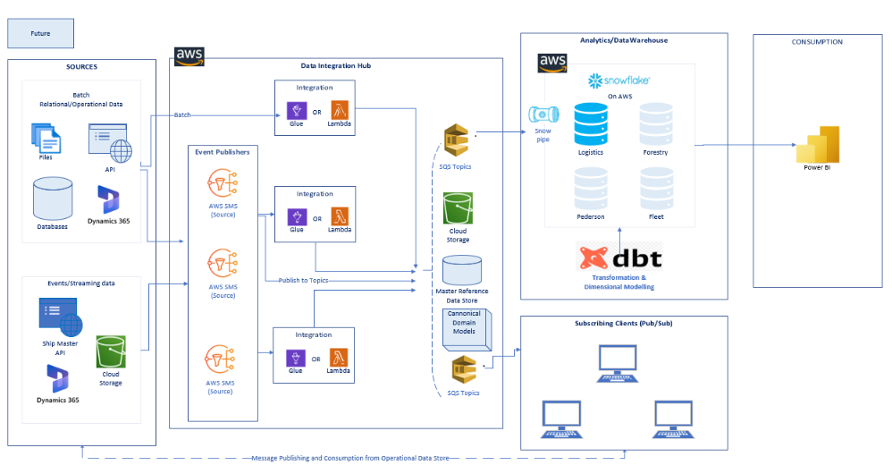
Figure 4 Recommended Tech Stack - AWS Snowflake
The above architecture features:
- Lambda architecture supporting Batch & Event driven design.
- Data Integration Hub:
- Replace all the direct custom point-to-point integrations with a structured cloud-based integration platform.
- Remove all application integrations requiring master or reference data direct with master data systems.
- Remove all application integrations with the intermediate data stores.
- Based pre-dominantly on Near-Real-Time Events, Integrations that take place in near real time enables systems to communicate and react to data updates as they occur. This contrasts with the traditional request/response messaging pattern where data is updated at intervals or as a response to a user-initiated request. ​
  - Event driven applications would receive a notification of change as it occurs and can notify you as it happens.
  - Eliminating the need for daily batch processes transferring hundreds of records.​
  - Event based integration also ensure resilience, scalability and extensibility.
- Near real time data sharing is enabled through event routers via pub/sub model using AWS Simple Notification Service (SNS) and Simple Queue Service (SQS).
- Allowing data publishing, sharing and subscription to:
  - external parties
  - applications
  - operational reporting
  - data warehouse
- Data Volume and Velocity

  - Specifications around DW SQL server
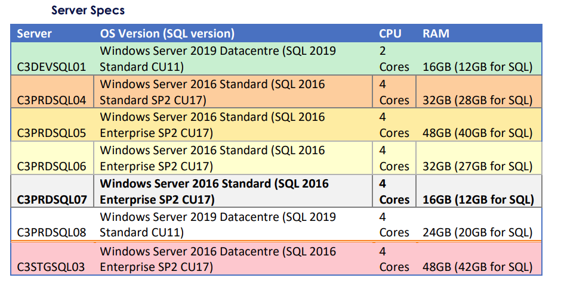
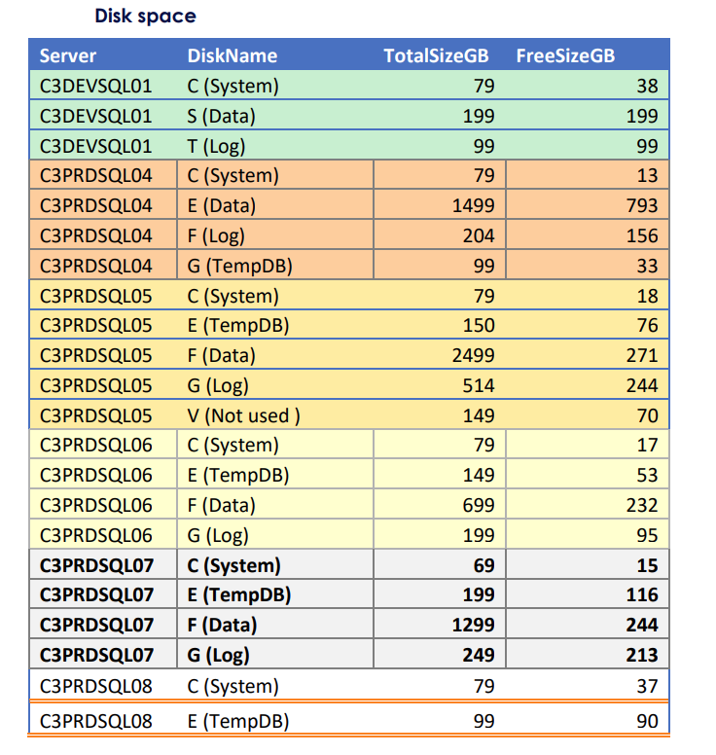
  - Data Velocity and Real-Time Requirements
As per the discussions and the discovery document the following are the data sources and the data types to be considered
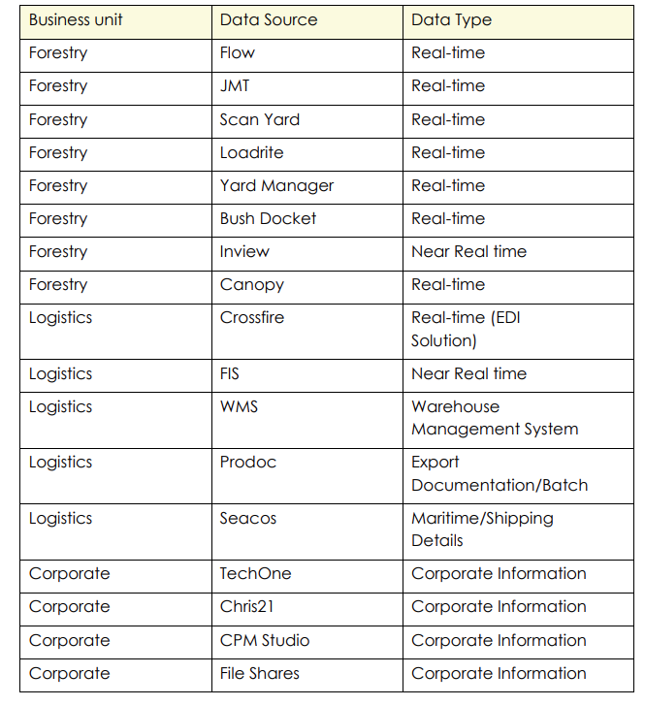
  - Scalability and Capacity Planning

This section focuses on scalability and capacity planning for the modern data platform. We define the expected growth patterns, data storage requirements, and the ability to handle increasing data volumes and processing workloads over time.
- Scalability Requirements
Describe the expected growth in data volume and user demand over a defined period (e.g., 1 year, 3 years, 5 years). Address how the data infrastructure should scale to handle this growth effectively.
- Data Storage Scalability
Specify how the data storage capacity should scale to accommodate increasing data volumes over time. Consider both structured and unstructured data.
- Data Processing Scalability
Address how data processing capabilities (e.g., ETL, data analytics, machine learning) should scale to handle larger datasets and increasing processing requirements.
- Horizontal Scaling
Define the strategy for horizontal scaling, including adding more servers or nodes to distribute the workload and increase capacity.
- Vertical Scaling
Describe the approach for vertical scaling, involving increasing the resources (e.g., CPU, memory) of individual servers to handle larger workloads.
- Auto-scaling Requirements
If applicable, specify whether the data infrastructure should support automatic scaling based on predefined triggers or performance thresholds.

- Data Backup and Recovery Scalability
Describe how data backup and recovery processes should scale as data volume and storage needs increase.

- Cloud Infrastructure Considerations
If you are using cloud-based data storage and processing solutions, outline how scalability will be achieved within the chosen cloud provider's environment.

- Disaster Recovery Planning
Describe the disaster recovery strategy and how it aligns with the scalability requirements to ensure business continuity.
- Monitoring and Alerting for Scalability
Specify the monitoring metrics and alerting mechanisms to track resource utilization and identify potential scalability issues.
- Implementation roadmap
  - Epics & User stories
Epic | User Story | Phase | Success criteria | Responsibility

  - Implementation plan & roadmap

- Appendix
  - Data Mesh
A data mesh architecture is a decentralized approach that enables domain teams to perform cross-domain data analysis on their own. At its core is the domain, with its responsible team, and its operational and analytical data. The domain team ingests operational data and builds analytical data models as data products to perform their own analysis. It may also choose to publish data products with data contracts to serve other domains’ data needs.
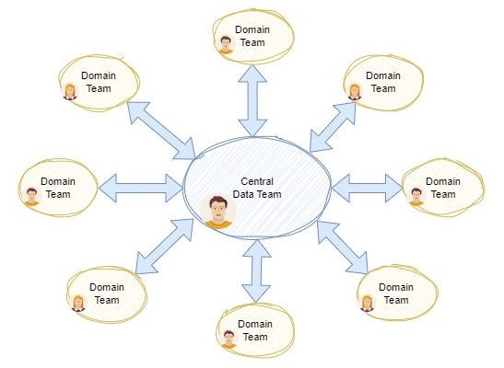
Figure 4 Data Mesh Overview
The domain team agrees with others on global policies, such as interoperability, security, and documentation standards in a federated governance group, so that domain teams know how to discover, understand and use data products available in the data mesh. The self-serve domain-agnostic data platform, provided by the data platform team, enables domain teams to easily build their own data products and do their own analysis effectively. An enabling team guides domain teams on how to model analytical data, use the data platform, and build and maintain interoperable data products.
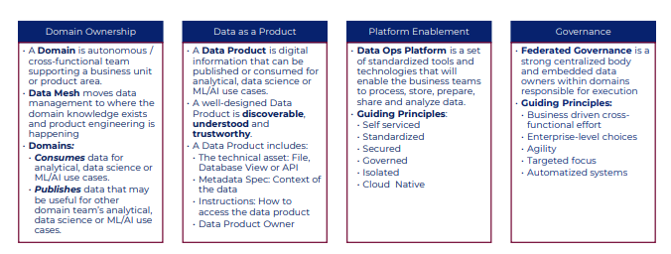
The key benefits will be: -
- Empower teams by allowing them to decide how best to implement their services.
- To leverage shared infrastructure so the organisation can achieve some economies of scale.
- A self-service "data services platform" supported by a team of data product and platform owners that collaborate to define some common governance around operation.

  - Current State Collateral Referenced
    - Infrastructure topology
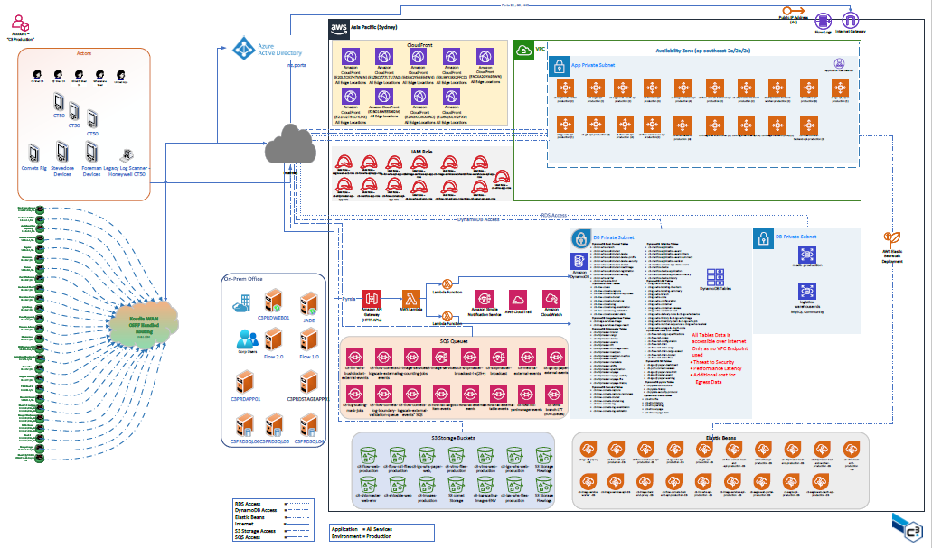
Figure 5 - Current State System Topology
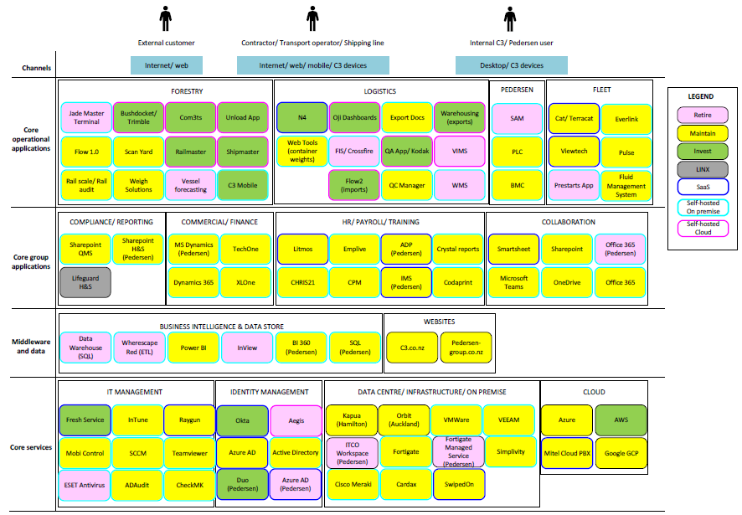
Figure 6 - Current State System Topology

Line-of-business – supported by systems specific to the operations the business executes.

